# Website Planning Document

## Site Name

Bountiful Bites Express

## Logo

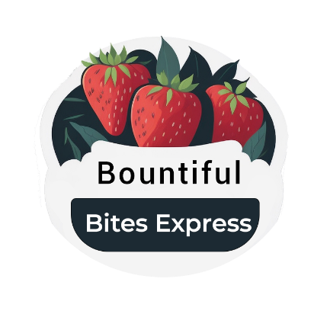

## Site Purpose

The purpose of the website is to create an engaging online platform that serves as a hub for Bountiful Foods, connecting their physical storefront in Carlsbad, California, with their fleet of food trucks covering the coastal areas from Los Angeles to San Diego. This website aims to showcase the company's commitment to offering fresh, locally grown, and organic food options to both the local population and visiting tourists. It serves as a convenient and user-friendly interface for customers to explore and purchase a variety of fruits, produce, made-to-order fruit drinks, and fruit bags. By emphasizing healthy eating, organic bounty, and convenience, the website aims to provide an immersive and enjoyable experience that promotes the values of sustainability and well-being.

## Target Audience and Scenarios

The target audience for the Bountiful Foods website consists of individuals who value fresh, organic, and locally sourced food options. They are health-conscious and seek convenient ways to incorporate nutritious choices into their lifestyle. Here are two examples of possible audience segments:

1. Health-Conscious Locals:

Description: Active and environmentally conscious individuals living in the coastal areas of California.

Demographics: Both males and females, aged 25-40.

Characteristics: They prioritize healthy eating, sustainability, and supporting local businesses. They are likely to have disposable income and are willing to pay a premium for high-quality organic food.

1. Tourists and Travelers:

Description: Visitors from various locations who are exploring the coastal areas of California.

Demographics: Both males and females, aged 18-55.

Characteristics: They are interested in experiencing local flavors and seeking out healthy dining options during their travels. They appreciate the convenience of on-the-go food options, such as food trucks, while also prioritizing fresh and organic choices.

Scenarios:  
Scenario 1: Sarah, the Health-Conscious Local

Description: Sarah is a 32-year-old yoga instructor and health enthusiast living in Carlsbad, California.

Scenario: Sarah has just finished her yoga class and is looking for a nutritious post-workout snack. She visits the Bountiful Foods website to browse through their selection of organic fruit bags and made-to-order fruit drinks. She appreciates the website's easy navigation, vibrant visuals of fresh produce, and detailed information about the nutritional benefits of each item. She selects a customized fruit bag and places an order for pickup at the storefront.

Scenario 2: Mark, the Traveling Foodie

Description: Mark is a 28-year-old adventurous traveler from New York who is exploring the coastal areas of California.

Scenario: Mark is passionate about trying local and sustainable food options wherever he goes. While visiting the coastal cities, he stumbles upon a Bountiful Foods food truck and enjoys a delicious organic fruit drink. Intrigued, he visits the Bountiful Foods website to learn more about their offerings. The website impresses him with its interactive map displaying the locations of their food trucks and storefront. Mark uses the website to locate the nearest food truck to his current location and plans to visit it for a healthy lunch the next day.

Scenario 3: Emily, the Vegan Visitor

Description: Emily is a 40-year-old vegan traveler from London who is visiting the coastal areas of California with her family.

Scenario: Emily and her family are seeking vegan-friendly dining options during their vacation. She discovers the Bountiful Foods website, which highlights their commitment to organic and locally sourced ingredients. Emily explores the website's dedicated section for vegan offerings and finds a variety of plant-based fruit bags, salads, and smoothies. The website provides detailed ingredient lists and allergen information, giving Emily peace of mind. She places an online order for delivery to their vacation rental, ensuring her family can enjoy healthy and vegan meals throughout their stay.

## Site Map

**Home**

**Resources**

**About Us**

**Fresh**

External links

Contact us

Made to Order

Info about us

Products

## Color Scheme & Typography

|  |  |  |  |
| --- | --- | --- | --- |
| **Element** | **Font-family** | **Font-size** | **Color** |
| Header | Poppins | 30px | White |
| Navigation | Poppins | 20px | White |
| Footer | Poppins | 24px | White |
| h1 | Poppins | 30px | #333333 |
| h2 | Poppins | 24px | #333333 |
| h3 | Poppins | 20px | #666666 |
| Paragraph | Sans-serif | 16px | White |

## Wireframe Sketches

